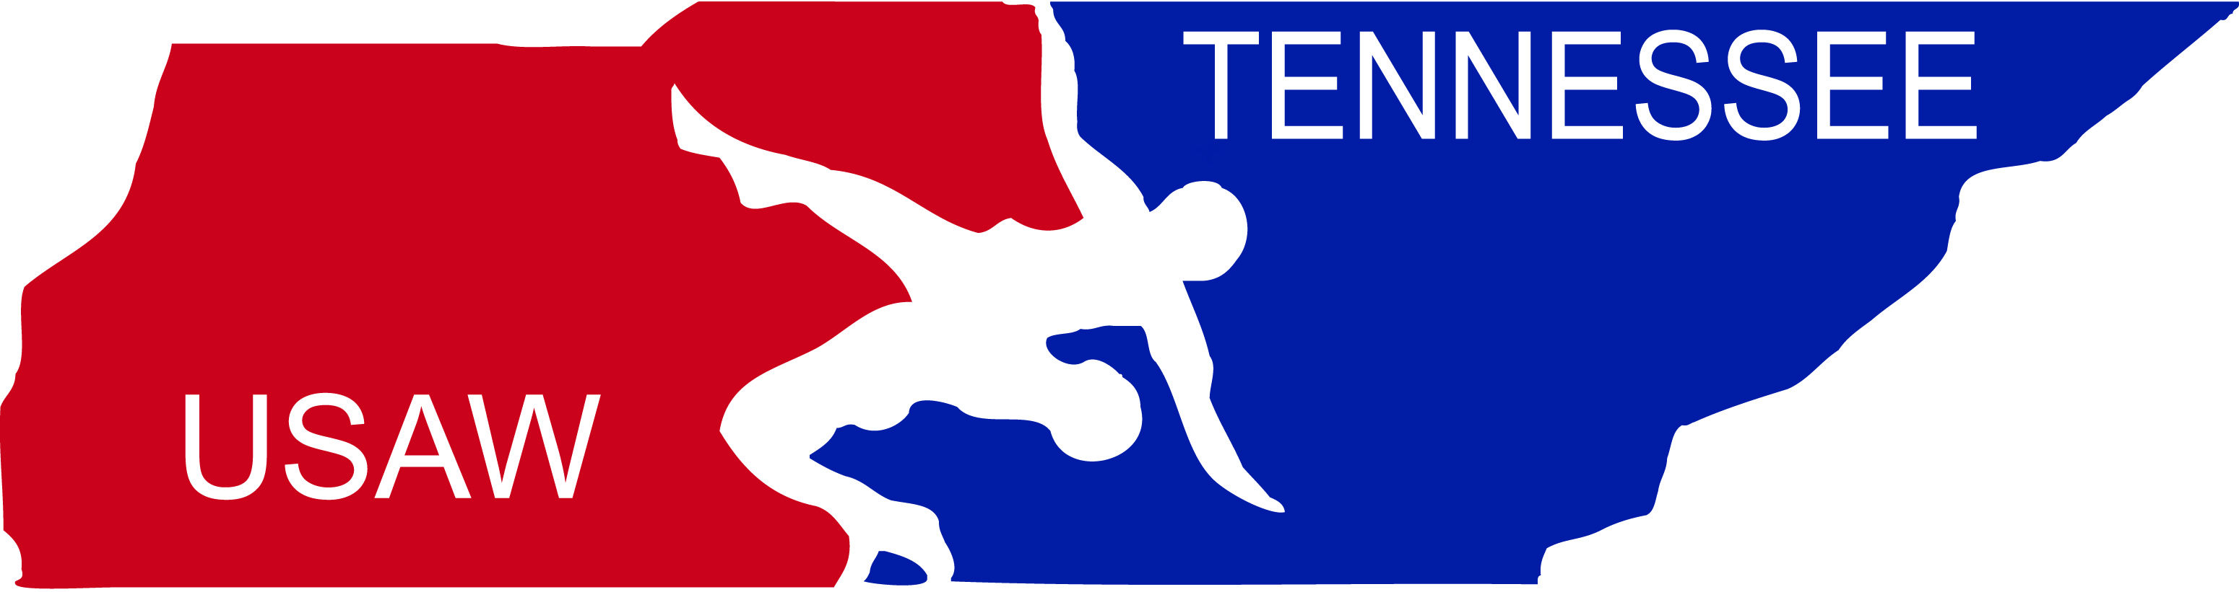  Tennessee Wrestling Federation |  | 

To whom it may concern,
I would like to introduce __________________________________. He is representing Team Tennessee at the USA Wrestling National Duals Championships. USA Wrestling/TWF (Tennessee Wrestling Federation) is a volunteer organization serving the amateur wrestling community of Tennessee. We provide programs for young people who participate in wrestling, including coaching, transportation, housing, meals, entry fees and a training camp prior to their trips to the nationals. While USA Wrestling/TWF has raised a portion of the cost for the team, each wrestler must pay a significant portion of the expenses himself/herself. We are asking for your help in that effort. Any contribution you make to assist this athlete in pursuing his dreams will be greatly appreciated. This wrestler can accept cash or check but the organization prefers checks. Please note that donations are tax deductable and in order for your donation to be a deduction you must write it in the form of a check. If you prefer your contribution to be tax deductible, you must write your check to the “Tennessee Wrestling Federation” account and not directly to the wrestler (Please note the wrestlers name in the memo line). The USAW tax-exempt number is 36-2667348. Thank you in advance for your generosity and commitment to this talented young person. It will go a long way in helping allow this athlete a rewarding educational opportunity and a chance to compete in the nation’s most challenging and prestigious national wrestling competition at these age groups.
Sincerely,
Mike Hatcher
State Chairperson of USA Wrestling/TWF (Tennessee Wrestling Federation)

