Team Tornado Wrestling Club
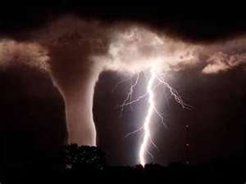
www.teamtornado.teampages.com
The Team Tornado Wrestling Club will host a fall folk-style season this year in order to prep athletes for their upcoming high school season. Team Tornado will travel to several tournaments including:
- The Super 32 Qualifier in Georgia
- The Blue Raider Triple Crown in Nashville
- The Prestigious Super 32 (You must qualify)

The season will run from August 22nd through October 22nd. Practices will be in the King College wrestling room in Bristol, TN from 6:30-8:00 PM on Monday, Tuesday, and Thursday. USA Wrestling Cards are required (if you are a Team Tornado Freestyle wrestler the cards are good from the end of August for a full calendar year). Therefore, if you purchase a USA card now it will be taken out of the cost for the freestyle session in the summer. Cost for this club session will be $100 (This does not include a USA Card). That is about $4 a practice to put into perspective. Athletes of all ages K-12 are invited. Please contact me with any questions at dharrison@king.edu or on my cell at 423-593-8348.

Derek Harrison
Tennessee Wrestling Federation Eastern Director
King College Wrestling Assistant
Team Tornado Head Coach
Tennessee Junior National Team Coach 2010, 2011

